**Student Information System (SIS)**

Software Requirements Specification (SRS)

Version 1.6

Contents

1 Revision History 4

2 Purpose 6

2.1 Introduction 6

2.2 Overview 8

2.3 Glossary 10

3 Requirements Specification 10

3.1 Functional Requirements 10

3.1.1 Access SIS home page 10

3.1.2 Login 11

3.1.3 Logout 11

3.1.4 Update Profile 12

3.1.5 View attendance 12

3.1.6 Update attendance 13

3.1.7 View progress 13

3.1.8 Update progress 14

3.1.9 View grades 14

3.1.10 Update grades 15

3.1.11 View message center 16

3.1.12 Communicate with the other users through the message center 16

3.1.13 Set objectives to IEP student 17

3.1.14 View IEP student progress 17

3.1.15 Update IEP student progress 18

3.1.16 Student/Parent: View attendance 19

3.1.17 Student/Parent: View progress 19

3.1.18 Student/Parent: View grades 20

3.1.19 Prospective students 20

3.1.20 Update prospective students page 21

3.1.21 Submit online application 22

3.1.22 Track application status 23

3.1.23 View all new applications 23

3.1.24 Update application 24

3.1.25 Update admission status 25

3.1.26 Create class and schedules 26

3.1.27 View teachers 27

3.1.28 Add teacher 27

3.1.29 Update teacher 28

3.1.30 Enroll new students 29

3.1.31 View student records 30

3.1.32 Updated student records 31

3.1.33 Handle state reports 32

3.1.34 View ad-hoc reports 33

3.1.35 Mobile Login 34

3.1.36 Mobile Logout 34

3.1.37 Mobile menu options screen 35

3.1.38 Mobile view message center 35

3.1.39 Mobile view schedules 36

3.1.40 Mobile view score card 36

4 System Architecture Design 37

4.1 Overview 37

4.2 System Architecture Design – Non-functional characteristics 41

5 Database Schema Design 42

5.1 Entity Relationship Diagrams 42

5.2 Database Table Descriptions 44

6 System Documentation 45

6.1 Common Pages 45

6.2 Public user Pages 45

6.3 Administrator Portal 46

6.3.1.1 Administrator Home page 46

6.3.1.2 SIS System Management 47

6.3.1.2.1 SIS Content Maintenance 47

6.3.1.2.2 School year Maintenance 48

6.3.1.2.3 Grade Level Maintenance 48

6.3.1.2.4 Subject Maintenance 49

6.3.1.2.5 Period Maintenance 49

6.3.1.2.6 Teacher/Subject Schedule Maintenance 49

6.3.1.3 Admission Management 49

6.3.1.4 Teacher Management 49

6.3.1.5 Student Management 49

6.3.1.6 Reports Management 49

6.4 Teacher Portal 49

6.5 Student Portal 49

# Revision History

|  |  |  |
| --- | --- | --- |
| **Revision** | **Description of Revision** | **Date** |
| 1.0 | Initial Draft | 01/15/2013 |
| 1.1 | Added functional requirements with use cases | 01/22/2013 |
| 1.2 | Added system architecture design | 01/29/2013 |
| 1.3 | Updated the use case diagram.  Added following new use cases:   * Mobile view message center * Mobile view schedules * Mobile view score card * Mobile log in * Mobile menu option screen * Mobile log out   Updated the following use cases:   * Set objectives to IEP student * View IEP student progress * Update IEP student progress * Prospective students * Update prospective student’s page * Create Class and schedules * Enroll new students * Handle State report   Updated system architecture design diagram for mobile web.  Updated sequence diagram for bean load process.  Updated Presentation tier for Mobile Web Architecture.  Updated Business Object tier for bean load process.  Updated Security for SSL needs.  Added Database schema design | 02/05/2013 |
| 1.4 | Made following changes to the database schema:   * Updated table and column names to follow consistent naming conventions and used the camel case for both entities and attributes. * Renamed StudentEnrollment to StudentGradeLevel. * Removed GradeLevelId column form StudentGrade table. * Renamed StudentGrade to StudentScoreCard. * Removed GradeLevelSubjects table, this table is no longer needed. * Removed GradeLevelId from SchedulesTeacherAssignment table. * Renamed SchedulesTeacherAssignment to SubjectSchedule. * Added new StudentSubjectSchedule table. * Removed GradeLevelId from AttendanceTracking table. * Added GoalTitle column to the IepGoals table. * Added GoalDescription column to the IepGoals table. * Added StartDate column to the IepGoals table. * Added EndDate column to the IepGoals table.   Renamed User table to Users.  Priority for mobile Use cases are changed to Conditional | 02/11/2012 |
| 1.5 | Allocate assignment (in teacher module) and cafeteria provision (in student module) is removed in the proposal section. | 02/18/2013 |
| 1.6 | System Documentation updated | 04/22/2013 |

# Purpose

## Introduction

The main intent of SIS application is to provide a solution to automate the schools day to day functions such as: student admission, student enrollment, and student grade management. At the same time providing a system to accurately store and manage all student information which would allow generating accurate reports required by the state such as PSIS. SIS creates a collaborative environment for parents, teachers and students to work together to improve the student performance. The primary beneficiaries of this application are teachers, students, parents, and administrative staff members. The features/functions of SIS would divide into multiple modules to target different users of the system, which includes a student admission workflow process, special education management (IEP), teachers’ portal, parent/student portal, report module, user and role management. SIS enables each user login with secured credentials registered with the application and allows access to the functionality designated to only that user role.

Admin workflow process provides an automated streamlined approach to manage student admission process. This workflow process will be triggered by the system either by submitting on-line application forms through SIS web application by parents or by entering student information based on the submitted hard copy of the application. SIS application controls the workflow by moving into various steps after an appropriate review and approvals. In each step of the workflow, system assigns a unique status to track the life of the workflow uniquely. The various statuses of the workflow include: Application Submitted, Application Review In-progress, In-person Interview Requested, In-person Interview Completed and Admission Granted. Along with admissions and enrollment, admin users can manage staff and courses.

Individualized Education Plan (IEP) allows schools to store information regarding the students with special education needs. The access to IEP is restricted to strictly authorized users only because of the sensitivity of the data. Essentially, it is used by the special education teachers, school psychologists, IEP coordinators, to enter individualized education plans for students with disabilities. This module would allow users to store files, recordings and videos. For instance, the school psychologist worked with the special education student on some goals or objectives. Using the iPad or any other device, the school psychologist recorded the session. The school psychologist uploads the video to the web server so that the file is accessible to all the “team” working with the student. The video can be used by the team to discuss new objectives or observations based on the student’s behavior.

Teacher portal module would be mainly used by teachers to perform their day to day activities effectively. . This portal also provides an ability to manage the attendance and grades for all students. In addition to this, it allows teachers to collaborate and communicate effectively with students and parents by sending messages or real time feedback on student’s performance.

Student/parent portal module is mainly intended for students/parents. Using this portal, students/parents would be able to view the grades, attendance status, and feedback/comments from the teachers and can effectively collaborate and communicate with teachers by sending messages or inquiries. User/Role management process would allow administrative users to create various roles and users to secure the application’s functionality from un-authorized users.

Report modules would provide administrative users and educational departments to generate various reports by selecting various criteria. Users would be able to accurately generate student information required by the state such as PSIS (Public School Information Systems). Users would be able to generate the reports either in web page or in excel sheet.

## Overview

There are four categories of users of the system: Administrative user, the parent/student user, teacher user and the public user. These users and the action each of them can perform on the system are listed in the use case diagram below.

Administrative User

Parent/Student

Teacher

Public User

## Glossary

|  |  |
| --- | --- |
| **Term** | **Definition** |
| SIS | Student Information System |
| IEP | Individualized Education Plan |
| Data Entry | Form filled out and submitted by user. |
| Web Site | A place on the world wide web |
| Screen | A specific UI on the SIS web site |
| TBD | To be decided |
| TBN | To be named |
| QA | Quality assurance |
| SRS | Software Requirements Specification |

# Requirements Specification

## Functional Requirements

### Access SIS home page

|  |  |
| --- | --- |
| **Use case name** | **Access SIS home page** |
| **Actors** | Administrative user, Teachers, Parent/Student, Public users |
| **Priority** | Essential |
| **Description** | Users are going to access the SIS from a hosted web url. The home page gives an overview of SIS application and provides an option to login for registered users. Other public users can browse and access the content like inquiries, submit new inquiries, submit new applications and track application status. |
| **Data** | URL |
| **Stimulus** | None |
| **Response** | When users enter SIS url in their browser, it displays the home screen. |
| **Comments** | All users |

### Login

|  |  |
| --- | --- |
| **Use case name** | **Log In** |
| **Actors** | Administrative user, Teachers, Parent/Student |
| **Priority** | Essential |
| **Description** | After user submitting the user name and password, the system will performs the validation and display the respective interface based on the user type. An error message will be displayed if the user name is not found or the password doesn’t match with the one in the system. |
| **Data** | User name, Password |
| **Stimulus** | Log In command |
| **Response** | If log in is successful, system will display welcome scree according to the user type. Otherwise error message will be displayed |
| **Comments** | 3 types of users – Administrative user, Teachers, Parent/Student |

### Logout

|  |  |
| --- | --- |
| **Use case name** | **Log Out** |
| **Actors** | Administrative user, Teachers, Parent/Student |
| **Priority** | Essential |
| **Description** | After user click on Log out button or if the user is inactive for a certain length of time, the system will not allow them access without a re-log in. |
| **Data** | Button click, or Session time out |
| **Stimulus** | Log Out command |
| **Response** | Log Out message Or a redirect to Log In screen. |
| **Comments** | 3 types of users – Administrative user, Teachers, Parent/Student |

### Update Profile

|  |  |
| --- | --- |
| **Use case name** | **Update Profile** |
| **Actors** | Administrative user, Teachers, Parent/Student |
| **Priority** | Essential |
| **Description** | User will click on the update profile link and it allows users to modify,   * Contact details * Communication address * Change password |
| **Data** | Contact details, communication address and new password |
| **Stimulus** | Update Profile command |
| **Response** | It displays a confirmation message if the update is successful otherwise display an error message. |
| **Comments** | 3 types of users – Administrative user, Teachers, Parent/Student |

### View attendance

|  |  |
| --- | --- |
| **Use case name** | **View attendance** |
| **Actors** | Teachers |
| **Priority** | Essential |
| **Description** | Teacher will click on the view attendance link and it will ask user to choose a class from list of all assigned classes to the teacher. Once teacher selects a class, it will display list of student attendance details by day/week/month. |
| **Data** | Class ID, filter type day/week/month |
| **Stimulus** | View attendance command |
| **Response** | It displays tabular list of attendance details for all students. |
| **Comments** | Teachers |

### Update attendance

|  |  |
| --- | --- |
| **Use case name** | **Update attendance** |
| **Actors** | Teachers |
| **Priority** | Essential |
| **Description** | Teacher will click on the view attendance link and it will ask user to choose a class from list of all assigned classes to the teacher. Once teacher selects a class, it will display list of student attendance details by day/week/month in edit mode. Teacher clicks on update attendance button to submit the attendance details. |
| **Data** | Class ID, filter type day/week/month |
| **Stimulus** | Update attendance command |
| **Response** | It displays a confirmation message if the update is successful otherwise display an error message. |
| **Comments** | Teachers |

### View progress

|  |  |
| --- | --- |
| **Use case name** | **View progress** |
| **Actors** | Teachers |
| **Priority** | Essential |
| **Description** | Teacher will click on the view progress link and it will ask user to choose a class from list of all assigned classes to the teacher. Once teacher selects a class, it will display list of all students and their progress. |
| **Data** | Class ID |
| **Stimulus** | View progress command |
| **Response** | It displays tabular list of progress for all students. |
| **Comments** | Teachers |

### Update progress

|  |  |
| --- | --- |
| **Use case name** | **Update progress** |
| **Actors** | Teachers |
| **Priority** | Essential |
| **Description** | Teacher will click on the view progress link and it will ask user to choose a class from list of all assigned classes to the teacher. Once teacher selects a class, it will display list of all students and their progress. Teacher will select a student from the list to edit their progress. |
| **Data** | Class ID, Student ID, Progress Details |
| **Stimulus** | Update progress command |
| **Response** | It displays a confirmation message if the update is successful otherwise display an error message. |
| **Comments** | Teachers |

### View grades

|  |  |
| --- | --- |
| **Use case name** | **View grades** |
| **Actors** | Teachers |
| **Priority** | Essential |
| **Description** | Teacher will click on the view grades link and it will ask user to choose a class from list of all assigned classes to the teacher. Once teacher selects a class, it will display list of all students and their grades. |
| **Data** | Class ID |
| **Stimulus** | View grades command |
| **Response** | It displays tabular list of grades for all students. |
| **Comments** | Teachers |

### Update grades

|  |  |
| --- | --- |
| **Use case name** | **Update grades** |
| **Actors** | Teachers |
| **Priority** | Essential |
| **Description** | Teacher will click on the view grades link and it will ask user to choose a class from list of all assigned classes to the teacher. Once teacher selects a class, it will display list of all students and their grades. Teacher will select a student from the list to edit their grades. |
| **Data** | Class ID, Student ID, Grade details |
| **Stimulus** | Update grade command |
| **Response** | It displays a confirmation message if the update is successful otherwise display an error message. |
| **Comments** | Teachers |

### View message center

|  |  |
| --- | --- |
| **Use case name** | **View message center** |
| **Actors** | Teachers, Parent/Student |
| **Priority** | Essential |
| **Description** | User will click on the message center link to see the list of all incoming messages in their inbox from other users. User selects a message link to see the details. |
| **Data** | Message ID |
| **Stimulus** | Message center command |
| **Response** | It displays tabular list of all incoming messages from user’s inbox. |
| **Comments** | Teachers, Parent/Student |

### Communicate with the other users through the message center

|  |  |
| --- | --- |
| **Use case name** | **Communicate with other users through the message center** |
| **Actors** | Teachers, Parent/Student |
| **Priority** | Essential |
| **Description** | User will click on the message center link to see the list of all incoming messages in their inbox from other users. User selects a message link to see the details and selects a reply button to send response. User can also click on the compose button to create a new message and send it to single or multiple users. |
| **Data** | Subject, message, recipients |
| **Stimulus** | Send message command |
| **Response** | It displays a confirmation message if the message successfully sent otherwise display an error message. |
| **Comments** | Teachers, Parent/Student |

### Set objectives to IEP student

|  |  |
| --- | --- |
| **Use case name** | **Set objectives to IEP student** |
| **Actors** | Teachers |
| **Priority** | Essential |
| **Description** | Teacher clicks on the IEP link from the menu.  Teacher selects a class from the list of all assigned classes to her/him. The application displays tabular list of all IEP students from the selected class with links to “goals & objectives”, “view progress” and “update progress”.  Teacher selects “goals & objectives” link next to the student name.  It displays a one big text area for entering (multiline text) goals and objectives for the IEP student.  Teacher updates the goals, objectives and status.  Teacher clicks on submit button to save the changes. |
| **Data** | Class ID, Student ID, goals & objectives text from the text area and status. |
| **Stimulus** | Submit command |
| **Response** | It displays a confirmation message if it saves the changes successfully otherwise display an error message. |
| **Comments** | Teachers |

### View IEP student progress

|  |  |
| --- | --- |
| **Use case name** | **View IEP student progress** |
| **Actors** | Teachers |
| **Priority** | Essential |
| **Description** | Teacher clicks on the IEP link from the menu.  Teacher selects a class from the list of all assigned classes to her/him. The application displays tabular list of all IEP students from the selected class with links to “goals & objectives”, “view progress” and “update progress”.  Teacher selects “view progress” link next to the student name.  It displays the IEP student progress along with links to any shared files upload for review. |
| **Data** | Class ID, Student ID |
| **Stimulus** |  |
| **Response** | It displays the IEP student’s detailed progress information. |
| **Comments** | Teachers |

### Update IEP student progress

|  |  |
| --- | --- |
| **Use case name** | **Update IEP student progress** |
| **Actors** | Teachers |
| **Priority** | Essential |
| **Description** | Teacher clicks on the IEP link from the menu.  Teacher selects a class from the list of all assigned classes to her/him. The application displays tabular list of all IEP students from the selected class with links to “goals & objectives”, “view progress” and “update progress”.  Teacher selects “update progress” link next to the student name.  Teacher updates the progress and optionally uploads any files to share with other users and clicks on submit button to save the details. |
| **Data** | Class ID, Student ID, Progress Details, Optional files to upload. |
| **Stimulus** | Submit command |
| **Response** | It displays a confirmation message if it updates the details successfully otherwise display an error message. |
| **Comments** | Teachers |

### Student/Parent: View attendance

|  |  |
| --- | --- |
| **Use case name** | **View Attendance** |
| **Actors** | Parent/Student |
| **Priority** | Essential |
| **Description** | * Parent/Student will click on the view attendance link. * System will display the attendance details for the student. |
| **Data** | Attendance information |
| **Stimulus** | * View Attendance Link * Back command |
| **Response** | System displays the attendance details associated to the logged-in student. |
| **Comments** | Parent/Student will perform this function. |

### Student/Parent: View progress

|  |  |
| --- | --- |
| **Use case name** | **View Progress** |
| **Actors** | Parent/Student |
| **Priority** | Essential |
| **Description** | * Parent/Student will click on the View Progress link. * System will display the progress details for the student who is part of identified education plan program. |
| **Data** | IEP progress information |
| **Stimulus** | * View IEP Progress Link * Back command |
| **Response** | System displays the IEP progress details associated to the student. |
| **Comments** | Parent/Student will perform this function. |

### Student/Parent: View grades

|  |  |
| --- | --- |
| **Use case name** | **View Grades** |
| **Actors** | Parent/Student |
| **Priority** | Essential |
| **Description** | * Parent/Student will click on the View Grades link. * System will display the grades for the student. |
| **Data** | Student Information, subject and grade details. |
| **Stimulus** | * View Grades Link * Back command |
| **Response** | System displays the grade details associated to the student. |
| **Comments** | Parent/Student |

### Prospective students

|  |  |
| --- | --- |
| **Use case name** | **Prospective students** |
| **Actors** | Public User |
| **Priority** | Essential |
| **Description** | * User will click on the prospective student’s link on the application start up page. * This link will provide information for prospective students. The contents of this page will be loaded from a database configuration table, which will be maintained by the admin user. |
| **Data** | Meta data information needed for prospective students. |
| **Stimulus** | Dynamic page content will be loaded from a database table. |
| **Response** | Information for prospective students will be displayed. |
| **Comments** | Public User |

### Update prospective students page

|  |  |
| --- | --- |
| **Use case name** | **Update prospective students page** |
| **Actors** | Administrative User |
| **Priority** | Essential |
| **Description** | * The admin user clicks on update prospective student’s page. * System maintains the page contents in a database configuration table, possibly in a rich text format. * Application will load the page contents from database table and displays in a rich text editor for editing. * Once user modifies the page content, he/she will click on the save button to write to the database table. |
| **Data** | Meta data information needed for prospective students. |
| **Stimulus** | Save Button |
| **Response** | Application displays a confirmation message if it updates the information for prospective student’s successfully otherwise display an error message. |
| **Comments** | Administrative User |

### Submit online application

|  |  |
| --- | --- |
| **Use case name** | **Submit Online Application** |
| **Actors** | Public User |
| **Priority** | Essential |
| **Description** | * User will seek for the admission by submitting the online application form. * User will enter all the required fields that are needed for the online application. The details required to fill in online application is:   + Student personal details   + Student demo-graphic details.   + Student’s contact details * User clicks submit button. * System saves the entered details and automatically generates a tracking number. * System displays tracking number in the screen. Users will use this tacking number to track the status of their application. |
| **Data** | Student personal details, demo-graphic information, contact details and tracking number. |
| **Stimulus** | * Submit command * Cancel command |
| **Response** | System stores online application information and displays system generated tracking number. |
| **Comments** | Public User |

### Track application status

|  |  |
| --- | --- |
| **Use case name** | **Track Application Status** |
| **Actors** | Public User |
| **Priority** | Essential |
| **Description** | * Public user will track the application status using tracking number. * User clicks the track application status link. * User enters tracking number and click submits button. * System displays the application status on the screen. |
| **Data** | Tracking number and the status of the tracking number. |
| **Stimulus** | * Submit command * Back command |
| **Response** | System displays the status of tracking number. |
| **Comments** | Public User |

### View all new applications

|  |  |
| --- | --- |
| **Use case name** | **View All new Applications** |
| **Actors** | Administrative User |
| **Priority** | Essential |
| **Description** | * Admin user clicks View All Applications link. * The system displays all the submitted application. * User will select a specific application to view the details of the specific application. * System displays the details of the selected application. |
| **Data** | List of submitted applications and the details of the selected application. |
| **Stimulus** | * Link to the selected application. * Back command |
| **Response** | Displays the details of the selected application. |
| **Comments** | Administrative User |

### Update application

|  |  |
| --- | --- |
| **Use case name** | **Update Application** |
| **Actors** | Administrative User |
| **Priority** | Essential |
| **Description** | * Admin user clicks View All Applications link. * The system displays all the submitted application. * User will select a specific application to update the details of the specific application. * System displays the details of the selected application in an editable mode. * User updates the application details and clicks Submit button. * The modified application details will be stored in the database. |
| **Data** | Application details |
| **Stimulus** | * Link to the selected application. * Submit command * Cancel command |
| **Response** | Displays the message stating that application details are saved. |
| **Comments** | Administrative User |

### Update admission status

|  |  |
| --- | --- |
| **Use case name** | **Update Admission Status** |
| **Actors** | Administrative User |
| **Priority** | Essential |
| **Description** | * Admin user clicks View All Applications link. * The system displays all the submitted application. * User will select a specific application to update the status of the specific application. * System displays the following details:   + Admission workflow Status history and comments   + Admission workflow status dropdown and editable text area to enter the comments.   + The possible admission workflow statuses are:     - Application Received     - Application Review In-progress     - In-person Interview Requested     - Admission Granted     - Admission Denied * User selects an appropriate admission status, enters comment and clicks the Save button. * The admission workflow status will be updated and comments will be saved. |
| **Data** | Admission workflow status history, comments, admission workflow status. |
| **Stimulus** | * Link to the selected application. * Save command * Cancel command |
| **Response** | Displays the message stating that admission workflow details are saved. |
| **Comments** | Administrative User |

### Create class and schedules

|  |  |
| --- | --- |
| **Use case name** | **Create class and schedules** |
| **Actors** | Administrative User |
| **Priority** | Essential |
| **Description** | * Admin user clicks Create class and schedules link. * Admission user selects a grade level and click search button. * System will display the list of subjects associated to the grade level. * Then Admin user will assign the teacher to each grade level and subject based on their available slots. |
| **Data** | Grade level, subject and teacher assignments will be done. |
| **Stimulus** | * Search command * Assign teachers to subject command |
| **Response** | Displays the message stating that Teachers are assigned. |
| **Comments** | Administrative User |

### View teachers

|  |  |
| --- | --- |
| **Use case name** | **View teachers** |
| **Actors** | Administrative User |
| **Priority** | Essential |
| **Description** | * Admin user clicks View teacher’s link. * System displays the search criteria to select the teacher. Search criteria includes the following teacher attributes:   + Teacher First Name   + Teacher Last Name   + Teacher Data of birth   + Teacher ID * User clicks on search button after entering the above information * System displays the teacher data. |
| **Data** | Teacher details. |
| **Stimulus** | * Search command * Link to select a specific teacher record. |
| **Response** | Displays the teacher information. |
| **Comments** | Administrative User |

### Add teacher

|  |  |
| --- | --- |
| **Use case name** | **Add teacher** |
| **Actors** | Administrative User |
| **Priority** | Essential |
| **Description** | * Admin user clicks Add teacher link. * User will enter all required fields that are needed for the teacher profile. The details needed for the teacher are:   + Teacher personal details   + Teacher demo-graphic details.   + Teacher contact details * User clicks submit button. * System saves the entered details into the system. |
| **Data** | Teacher personal details, demo-graphic information, contact details. |
| **Stimulus** | * Submit command * Cancel command |

### Update teacher

|  |  |
| --- | --- |
| **Use case name** | **Update teacher** |
| **Actors** | Administrative User |
| **Priority** | Essential |
| **Description** | * Admin user clicks View Teachers link. * System displays the search criteria to select the teacher. Search criteria includes the following teacher attributes:   + Teacher First Name   + Teacher Last Name   + Teacher Data of birth   + Teacher ID * User clicks on search button after entering the above information * System displays the teacher details. * User will click update button to update the teacher information. * User updates teacher details and clicks save button. * Teacher details will be saved. |
| **Data** | Teacher details. |
| **Stimulus** | * Search command * Update Link * Save command in update screen |

### Enroll new students

|  |  |
| --- | --- |
| **Use case name** | **Enroll Students** |
| **Actors** | Administrative User |
| **Priority** | Essential |
| **Description** | * Admin user clicks Enroll Students link. * Admission user selects a grade level and click search button. * System displays the list of regular and IEP students admitted for the selected grade level. * Admin user will assign the students to each grade level. |
| **Data** | Grade level and student assignments will be done. |
| **Stimulus** | * Search command * Assign students to grade level command |
| **Response** | Displays the message stating that Students are assigned to the grade level. |
| **Comments** | Administrative User |

### View student records

|  |  |
| --- | --- |
| **Use case name** | **View Student Records** |
| **Actors** | Administrative User |
| **Priority** | Essential |
| **Description** | * Admin user clicks View Student Records link. * System displays the search criteria to select the student. Search criteria includes the following student attributes:   + Student First Name   + Student Last Name   + Student Date of birth   + Student ID   + Student Grade level * User clicks on search button after entering the above information * The search will return one or more records and it displays the student record details in a tabular format along with an “edit” link next to each student record. |
| **Data** | Student record details. |
| **Stimulus** | * Search command * Link to select a specific student record. |
| **Response** | Displays the student information. |
| **Comments** | Administrative User |

### Updated student records

|  |  |
| --- | --- |
| **Use case name** | **Update Student Records** |
| **Actors** | Administrative User |
| **Priority** | Essential |
| **Description** | * Admin user clicks View Student Records link. * System displays the search criteria to select the student. Search criteria includes the following student attributes:   + Student First Name   + Student Last Name   + Student Date of birth   + Student ID   + Student Grade level * User clicks on search button after entering the above information * The search will return one or more records and it displays the student record details in a tabular format along with an “edit” link next to each student record. * User clicks on the edit link next to student name. * User updates health and other user demographics and clicks save button. * Student details will be saved. |
| **Data** | Student record details. |
| **Stimulus** | * Search command * Save command in update screen |
| **Response** | Updated the student health information and demographic information message will be displayed in the screen. |
| **Comments** | Administrative User |

### Handle state reports

|  |  |
| --- | --- |
| **Use case name** | **Handle State Reports** |
| **Actors** | Administrative User |
| **Priority** | Essential |
| **Description** | * Admin user clicks Handle State Report link. * System displays a year drop down and generate report button. * User selects a specific year and clicks on Generate report button. * System generates CAPT (Connecticut Academic Performance Test) report for the selected year. The format of CAPT is attached below. |
| **Data** | Student and their academic information. |
| **Stimulus** | * Generate reports command |
| **Response** | The reports will be generated. |
| **Comments** | Administrative User |

### View ad-hoc reports

|  |  |
| --- | --- |
| **Use case name** | **View Ad-hoc reports** |
| **Actors** | Administrative User |
| **Priority** | Essential |
| **Description** | * Admin user clicks View Ad-hoc link. * System displays the search criteria to select the student. Search criteria includes the following student attributes:   + Student First Name   + Student Last Name   + Student Data of birth   + Student ID   + Student Grade level * System shows “Generate Report” button. Such reports are:   + Applications Status Report   + Students Grade report   + Teachers Schedule report |
| **Data** | Student, Application and Teacher information. |
| **Stimulus** | * View reports command |
| **Response** | The selected reports will be generated. |
| **Comments** | Administrative User |

### Mobile Login

|  |  |
| --- | --- |
| **Use case name** | **Mobile Log In** |
| **Actors** | Teachers, Parent/Student |
| **Priority** | Conditional |
| **Description** | After user submitting the user name and password, the system will performs the validation and displays respective mobile menu options screen based on the user type. An error message will be displayed if the user name is not found or the password doesn’t match with the one in the system. |
| **Data** | User name, Password |
| **Stimulus** | Log In command |
| **Response** | If log in is successful, system will display respective mobile menu options based on the user type. Otherwise error message will be displayed |
| **Comments** | Teachers, Parent/Student |

### Mobile Logout

|  |  |
| --- | --- |
| **Use case name** | **Mobile Log Out** |
| **Actors** | Teachers, Parent/Student |
| **Priority** | Conditional |
| **Description** | Users will be redirected to login screen once he/she clicks on Log out button or if the user is inactive for a certain length of time. |
| **Data** | Button click, or Session time out |
| **Stimulus** | Log Out command |
| **Response** | Redirects to mobile Log In screen. |
| **Comments** | Teachers, Parent/Student |

### Mobile menu options screen

|  |  |
| --- | --- |
| **Use case name** | **Mobile menu options screen** |
| **Actors** | Teachers, Parent/Student |
| **Priority** | Conditional |
| **Description** | Once users successfully logs-in, they will be redirected to the mobile menu options screen. The menu options on this screen will vary based on the user type. |
| **Data** | None |
| **Stimulus** | Teachers: Message center, Schedules, Log Out  Parent/Student: Message center, Score card, Log Out |
| **Response** | Displays mobile menu options. |
| **Comments** | Teachers, Parent/Student |

### Mobile view message center

|  |  |
| --- | --- |
| **Use case name** | **Mobile view message center** |
| **Actors** | Teachers, Parent/Student |
| **Priority** | Conditional |
| **Description** | User will click on the message center link from the mobile view menu options to see the list of all incoming messages in their inbox from other users. User selects a message link to see the details. |
| **Data** | Message ID |
| **Stimulus** | Message center command, Back command |
| **Response** | It displays tabular list of all incoming messages from user’s inbox. |
| **Comments** | Teachers, Parent/Student |

### Mobile view schedules

|  |  |
| --- | --- |
| **Use case name** | **Mobile view schedules** |
| **Actors** | Teachers |
| **Priority** | Conditional |
| **Description** | Teacher will click on the schedules link from the mobile view menu options to see the list of her/his schedule. All schedules will be displayed in the screen. |
| **Data** | Teacher ID |
| **Stimulus** | Schedules command, Back command |
| **Response** | It displays tabular list of teacher’s schedule. |
| **Comments** | Teachers |

### Mobile view score card

|  |  |
| --- | --- |
| **Use case name** | **Mobile view score card** |
| **Actors** | Parent/Student |
| **Priority** | Conditional |
| **Description** | User will click on the score card link from the mobile view menu options. Application will display the current available grades for the student. |
| **Data** | Student ID |
| **Stimulus** | Score card command, Back command |
| **Response** | Application displays the current available grades for the student. |
| **Comments** | Parent/Student |

# System Architecture Design

## Overview

Student Information System (SIS) is a web based application which will be developed in Java/J2EE technologies and will be hosted in Glassfish application server. As SIS is web based application, it can be accessed through the pre-configured URL (uniform resource locator) from any computers and smartphones over the internet. This web application will follow the well-known industry standard MVC (Model View Controller) architecture. In addition to that, the application will be designed based on multi-tiered/multi-layered architecture. The detailed architecture diagram and its sequence diagram are depicted below:





* **Client Tier:**
  + Client tier represents the users of SIS and the different devices that are used by users to connect to it.
    - Users are: Admin Staff, Teacher, Student, Parent and Public User.
    - Potential Devices used (not limited to): Laptop, Desktop Computers, Smart phones, Tablets etc…
  + Users will access SIS by entering its URL in their browsers. Once URL is entered, browser will send the request to the web server through internet.
  + The components in this tier will be built based on the following technologies:
    - HTTP protocol will be used to send the request and receive the response from the server.
    - Industry standard web browsers will be used to access the application.
    - JavaScript will be used to handle the client side validation.
* **Presentation Tier:**
  + Presentation tier contains the View architectural components of MVC pattern.
  + The components in this layer are responsible for user interface screen display and its associated logic.
  + Once user completes their data entry and when they click Submit or Hyperlinks, the respective servlet or the methods attached to its managed bean will be invoked.
  + Apache web server will run separately and handles all web related requests such as session time out, http request and response handling etc. Apace web server will route the calls to Glass fish application server.
  + As this application receives the request from both standard web browsers and mobile web browsers, for better usability and readability experiences a user agent detector component will be developed. User agent detector will identify the user-agent of the requestor’s device (using HTTP request’s *user-agent* header attribute) and it redirects the requests to the appropriate web pages. For instance if the request is received from standard web browsers then it will redirect the request to standard web pages otherwise it will redirect the request to mobile web pages.
    - **Standard Web View Components/Pages:**
      * Standard web view components will be built based on the following technologies based on its suitable functional and technical needs:
        + HTML will be used to display the static pages.
        + JavaScript will be used to perform basic client level validation to avoid unnecessary server hits.
        + Style sheets will be used to define the consistent screen layouts, fonts, colors headers and menus across all screens of the application.
        + Java server pages (JSP) will be used to display and handle the dynamic content of the pages.
        + In JSP pages, custom tag libraries and JSTL (Java server tag libraries) will be used to handle the reusable display widgets and its data contents.
        + Java Server Faces (JSF) will be used to display and handle the dynamic content based to achieve event driven similar experience.
        + AJAX will be used to perform server side validation and pre-population of certain widgets based on the selection of the value in its previous widgets without refreshing entire web page.
    - **Mobile Web View Components/pages:**
      * Mobile web view components will be built based on the following technologies:
        + HTML will be used to display the static pages.
        + JavaScript will be used to perform basic client level validation to avoid unnecessary server hits.
        + Java server pages (JSP) will be used to display and handle the dynamic content of the pages.
        + jQuery framework and its associated style sheets will be used to design mobile web pages.
        + Firefox and its user-agent plug-in will be used to perform mobile web pages testing to identify different user agents.
        + iBBDemo2 tool will be used to test the mobile web pages from the desktop to simulate how they would function on iPhone devices.
* **Business Objects Tier**
  + Business object tier contains the Model and Controller architectural components of MVC pattern.
  + Controller components are responsible handling the request from JSP and JSF pages. Once it receives the request from the pages, based on the parameters submitted these components will control the flow of application by invoking the respective model components.
  + Controller components will be built based on the following technologies:
    - Servlet will be used to control the get and post method request from the pages.
    - Managed Bean will be used to control the request from JSF pages.
  + The creation of java beans reside in business objects tier. Controller components will interact with database while performing database operations (create, read, update and delete) through java beans using Java Persistence API. During this process, Entity Manager Factory, Persistence Unit and User Transaction classes will be used to perform database operations.
  + Model components are responsible handling the request from Servlets and Managed beans. Model components represent the real time physical entities such as School, Student, Teacher and logic business entities such as Enrollment, etc…In addition to that model components also contain any specific rules that are associated to its business process workflow.
  + Model components will be built based on the following technologies:
    - Managed Entity Bean – This java object represents the characteristics of real life physical objects with its appropriate getter and setter method to access those characteristics.
    - The respective Annotations will be used to map the managed bean to the physical database table.
* **Integration Tier**
  + Integration tier contains the components and framework that are used to connect the information tier in SIS application.
  + Integration tier components will be built based on the following technologies:
    - Java Persistence API framework will be used to map and populate the Student data model into java object models.
    - Entity Manager and User transactions objects will be used to handle user transactions.
* **Information Tier**
  + Information tier contains the database components that are used in SIS application.
  + Student database will be used to maintain the business data and audit data needed to meet SIS application’s business requirements.
  + In addition to that the meta data and configuration data needed for SIS application will be maintained in the database tables.
  + The student database will contain various tables such as:
  + Derby database will be used to build the Student database.
* **Distribution Tier**
  + Distribution tier contains the set of reusable components that are used in SIS application across various tiers. The list of reusable components include:
    - File Handler components
    - Message board handler components
    - Validation Utility components

## System Architecture Design – Non-functional characteristics

* **Scalability:**
  + Due to the layered architecture, components in each layer are loosely coupled. With this architecture, the application can be scaled (both vertically and horizontally) with minimal configuration without modifying the application’s code.
* **Performance:**
  + All the screens will be rendered within 2-3 seconds.
* **Manageability:**
  + Application will be designed and developed based on the industry standard J2EE design patterns and coding guidelines.
  + Configuration and Meta data information of SIS application will be stored in database tables. Due to this, application will be configured and maintained easily through these configuration tables without any code changes.
* **Usability:**
  + Consistent style sheets will be used for better usability experiences.
  + Based on screen layouts and functions, the respective buttons and links will be displayed.
* **Security:**
  + SIS application handles and process student information. This is one of the sensitive information. So, SSL certificates will be used to secure SIS application.
  + In addition to SSL, Users of this application will be provided with an appropriate user id and password to access the application.

# Database Schema Design

## Entity Relationship Diagrams

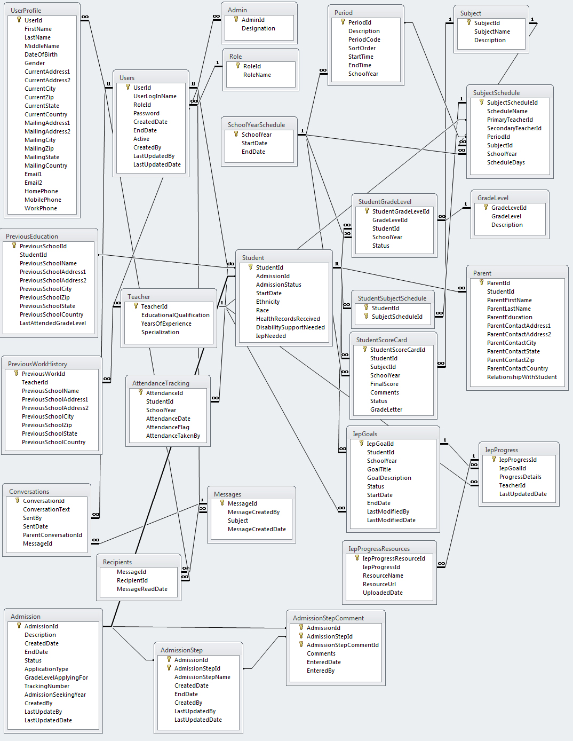

## Database Table Descriptions

|  |  |
| --- | --- |
| **Table Name** | **Table Description** |
| Admin | Admin is a type of user to SIS application. This table extends the user table. This table is used to maintain admin specific information. |
| Admission | This table is used to maintain and track the admission workflow. |
| AdmissionStep | This table is used to maintain and track the admission workflow steps. |
| AdmissionStepComment | This table is used to maintain and track the admission workflow step comments entered by the user. |
| AttendanceTracking | This table is used to track the attendance of the student in a given grade level for a particular day. |
| Conversation | This is table used for keeping track of all conversations between the uses by message id. |
| GradeLevel | This master table is used to maintain the grade level offered. |
| StudentSubjectSchedule | This table maintains the student subject enrollments. |
| IEPGoals | This table is used for storing goals and objectives of all IEP students. |
| IEPProgress | This is table is for keeping track of IEP student progress. |
| IEPProgressResources | Table for storing the shared resources of IEP students. |
| Messages | This is table contains the list of all composed message titles. |
| Parent | This table is used to maintain the parent details of the student. |
| Period | This master table is used to maintain periods and its timing of the school for a given school year. |
| PreviousEducation | This table is used to maintain the prior educational history of the student. |
| PreviousWorkHistory | This table is used to maintain the prior work history of the teacher. |
| Recipients | This table is used for keeping track of all recipients in the message center conversations. This table also keeps track of read and unread messages. |
| Role | This table is used to maintain the role of the users of SIS application. The different roles of  this application are: Student, Teacher and Admin |
| SubjectSchedule | This table is used to maintain the schedules for each subject by teacher and period.. |
| SchoolYearSchedule | This master table is used to maintain the school year and its corresponding start and  end date for the school. |
| Student | Student is a type of user to SIS application. This table extends the user table. This table is used to maintain student specific information such as Race, Ethnicity, and Health records etc... |
| StudentGradeLevel | This table is used to maintain the list of students enrolled for a given grade level. |
| StudentScoreCard | This table is used to maintain the scores of the subject for each student. |
| Subject | This table is used to maintain the list of subjects taught in the school. |
| Teacher | Teacher is a type of user to SIS application. This table extends the user table. This table is used to maintain teacher specific information such as educational qualification. |
| Users | This is a generic user table to track the users of the application. |
| UserProfile | This table is used to maintain user personal and demographic information. |

# System Documentation

Once Student Information System (SIS) application and Student database is configured successfully SIS application can be accessed through any standard web browsers using the following URL if SIS is deployed in desktop’s application server instance. <http://localhost:8080/SIS/faces/index.xhtml>. This URL displays the home page of SIS application. By default, application’s database script creates an administrator user with user name as “admin” and password as “admin”. With this admin user id and password, administrator can be able to login to SIS application. SIS application contains the following sub functionalities based on the role of the user.

## Common Pages

Common functionalities of SIS application are accessed by all authorized users of SIS application. They can be able to access these functions through the links provided in the top right side of each screens. Common modules include the following functions:

* **Login:** 
  + This screen provides ability for Teachers/Students to login to SIS application based on the valid user login name and password provided by Administrator.
  + System automatically creates unique user login name and password for each teacher whenever a new teacher is added. For students, it will be created once their admission is granted.
  + Administrator communicates user login name and password to the respective teachers and students.
* **Change Profile:**
  + Using this screen teachers and students can be able to update their user profiles including Contact Address, Email, Phone etc…
* **Change Password:**
  + Using this screen teachers and students can be able to update their passwords.
* **Logout:**
  + This link provides an option for user to logout from SIS application and application will redirect users to SIS home page.

## Public user Pages

SIS application provides the following features for Public users.

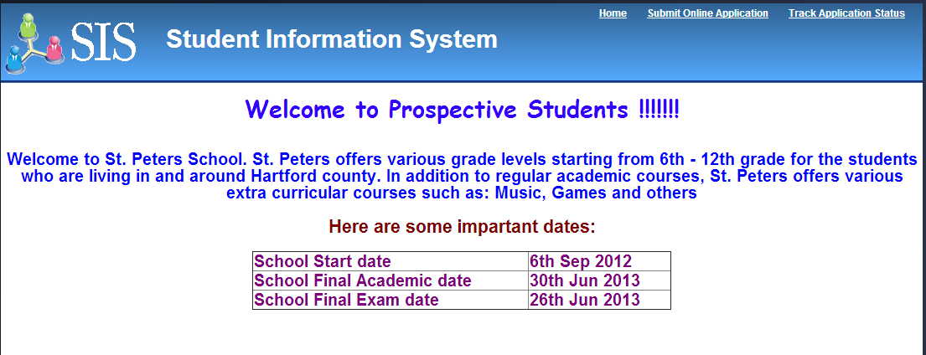

* **Prospective Students:**
  + This screen provides the detailed information about the school and its important dates.
  + Administrator of the application will update this screen through the content maintenance facility provided for admin users.
* **Submit Online Application:**
  + Using this screen, the prospective students or their parents will apply for the school for upcoming school year and grade level based on their interest.
  + Once the application is submitted, system initiates Admission Workflow automatically and puts in in-progress status and it will be listed in administrator’s queue for review and next steps.
  + In addition to that system provides a tracking number for public users to track the status of their application at point in time during the admission process.
* **Track Application Status:**
  + Using this screen, public user will be able to track the status of their application status.

## Administrator Portal

#### Administrator Home page

Admin users will be redirected to Admin home page as soon as they login to the SIS application using their user login and password. Administrator home page will provide the various menu options for administrators to perform various administrative related functions that includes SIS System Management, Admission Management, Teacher Management, Student Management and Reports Management.

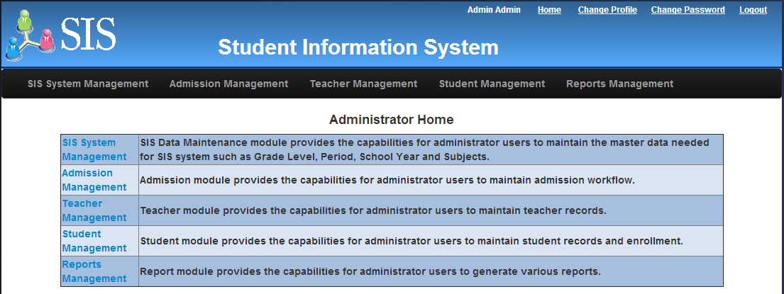

#### SIS System Management

Using System Management options, administrator will setup academic data that requires managing a school’s academic process for any specific school year. This information includes School year, Grade level, Subject, Period and Teacher/Subject schedules.

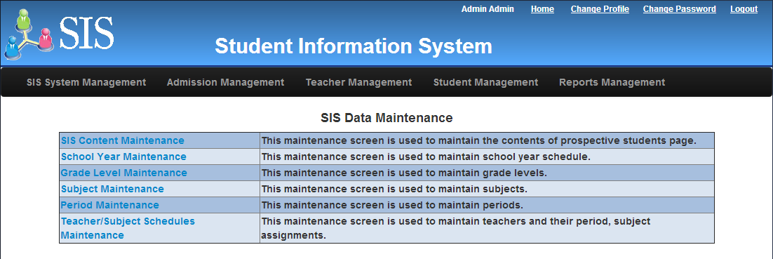

##### SIS Content Maintenance

* This screen will provide an option for Administrators to add and edit the content for prospective student’s page using the rich text editor.
* Updated contents will immediately available in Prospective Student page without any code changes and deployment.

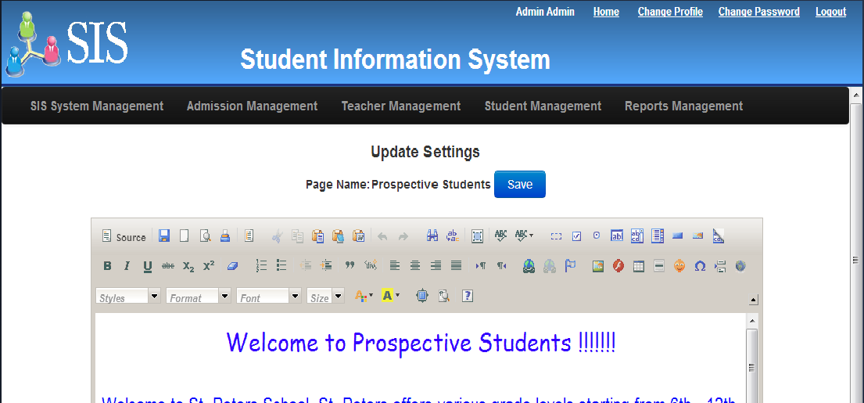

##### School year Maintenance

* This screen will provide an option for Administrators to add and edit school years.
* Administrator will update the current school year as active for all operational purposes and make other school years as inactive for reporting and other purposes.

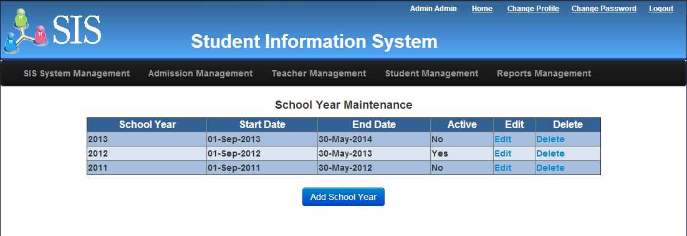

##### Grade Level Maintenance

* This screen will provide an option for Administrators to add and edit grade levels.
* Sort order attribute in grade level will define the order of grade level (lower to higher) offered in the school.

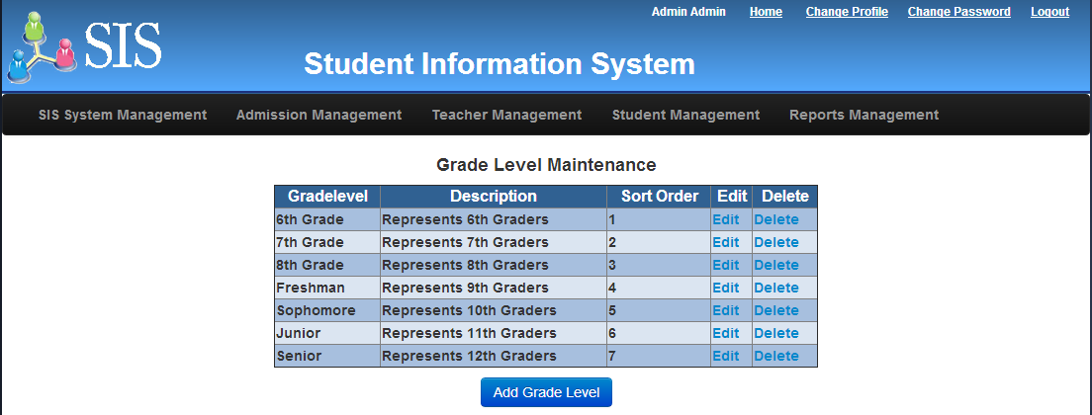

##### Subject Maintenance

* This screen will provide an option for Administrators to add and edit subjects that are offered in the school.

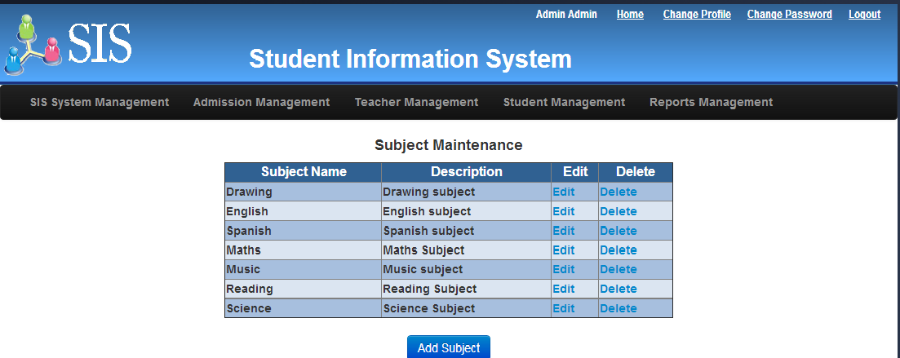

##### Period Maintenance

* This screen will provide an option for Administrators to add and edit periods for the selected school year.
* During the creation of period, this screen will provide an option to select start time, end time and sort order for the periods.

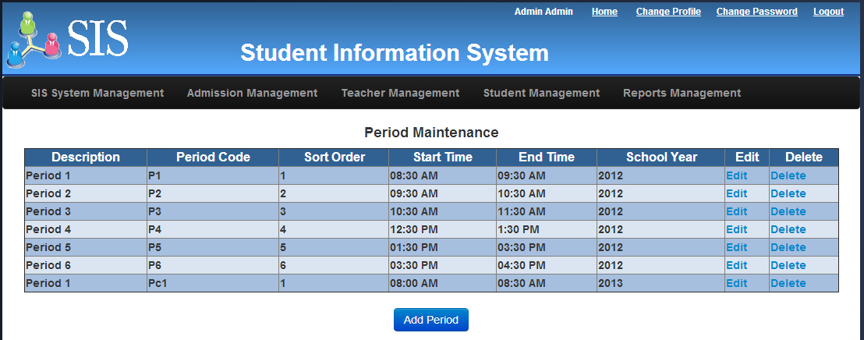

##### Teacher/Subject Schedule Maintenance

* This screen will provide an option for Administrators to assign teachers to the specific subjects and its corresponding periods for the selected school year.
* During the primary and secondary teacher assignment, system will perform an appropriate edits to avoid any conflict schedule assignments.

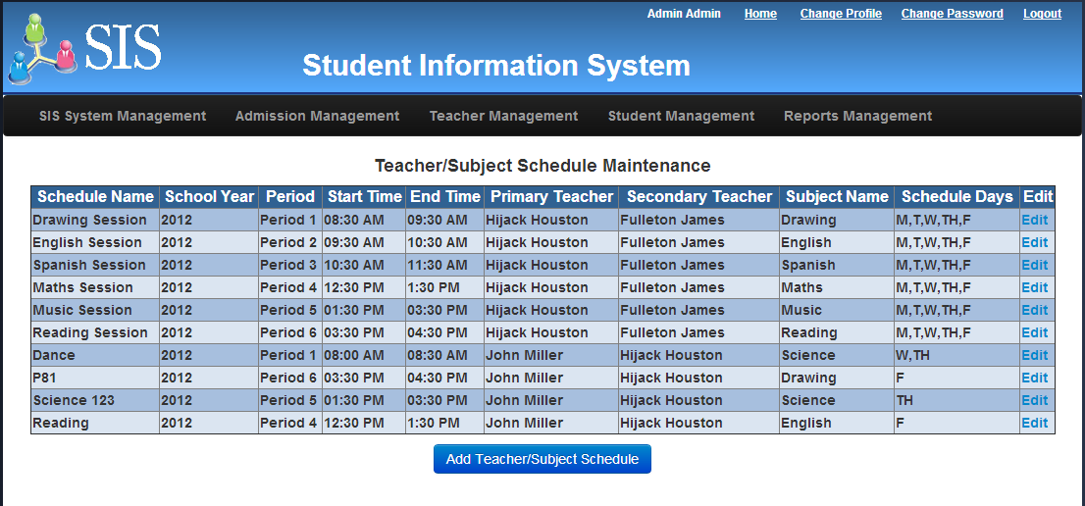

#### Admission Management

#### Teacher Management

* This screen will provide an option for Administrators to create and edit new teachers.
* Once teachers are created successfully, system automatically creates a user login name and default password.
* Administrator will provide user login name and password to the teachers. So that teachers can be able to login to SIS application to perform their academic functions such as Take Attendance, Update scores and grade letter.

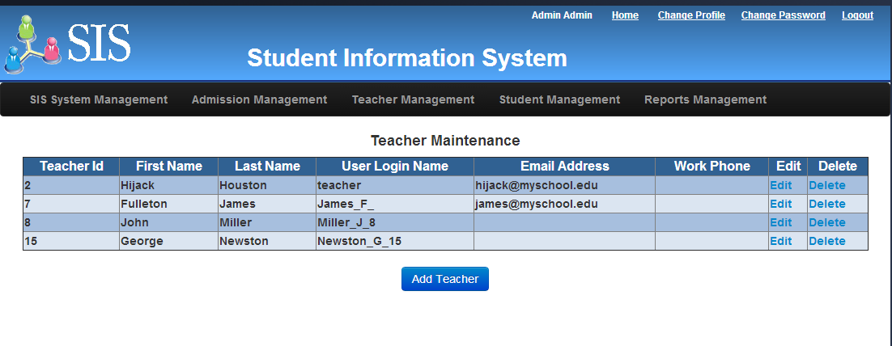

#### Student Management

#### Reports Management

## Teacher Portal

## Student Portal